**Driver Alertness Detection**

## A PROJECT REPORT

***Submitted by,***

**ASHFAQ UR RAHMAN H N – 20211CSE0615**

**MOHAMMED AZEEM A – 20211CSE0610**

**SAGAR H N – 20211CSE0619**

### *Under the guidance of,*

**Dr. MOHAMMED MUJEER ULLA**

***in partial fulfillment for the award of the degree of***

**BACHELOR OF TECHNOLOGY**

**IN**

**COMPUTER SCIENCE AND ENGINEERING**

**At**



**PRESIDENCY UNIVERSITY**

**BENGALURU**

**January 2025PRESIDENCY UNIVERSITY**

**SCHOOL OF COMPUTER SCIENCE ENGINEERING**

**CERTIFICATE**

This is to certify that the Project report **“Driver Alertness Detection”** being submitted by “Ashfaq Ur Rahman H N, Mohammed Azeem A, and Sagar H N” bearing roll number(s) “20211CSE0615, 20211CSE0610, and 20211CSE0619,” in partial fulfillment of the requirement for the award of the degree of Bachelor of Technology in Computer Science and Engineering is a bonafide work carried out under my supervision.

|  |  |
| --- | --- |
| **Dr MOHAMMED MUJEER ULLA**  Associate Professor  School of CSE&IS  Presidency University | **Dr. MOHAMMED ASIF T**  HOD  School of CSE&IS  Presidency University |

|  |  |  |
| --- | --- | --- |
| **Dr. L. SHAKKEERA**  Associate Dean  School of CSE  Presidency University | **Dr. MYDHILI NAIR**  Associate Dean  School of CSE  Presidency University | **Dr. SAMEERUDDIN KHAN**  Pro-VC School of Engineering  & Dean -School of CSE&IS  Presidency University |

**PRESIDENCY UNIVERSITY**

**SCHOOL OF COMPUTER SCIENCE ENGINEERING**

**DECLARATION**

We hereby declare that the work, which is being presented in the project report entitled **Driver Alertness Detection** in partial fulfilment for the award of Degree of **Bachelor of Technology** in **Computer Science and Engineering**, is a record of our own investigations carried under the guidance of **Dr MOHAMMED MUJEER ULLA, ASSOCIATE PROFESSOR,** **School of Computer Science Engineering, Presidency University, Bengaluru.**

We have not submitted the matter presented in this report anywhere for the award of any other Degree.

|  |  |
| --- | --- |
|  | **ASHFAQ UR RAHMAN H N – 20211CSE0615**  **MOHAMMED AZEEM A – 20211CSE0610**  **SAGAR H N – 20211CSE0619** |

**ABSTRACT**

Driver drowsiness and inattention are critical factors contributing to road accidents globally, often resulting in severe consequences. This project aims to address this issue by developing a **Driver Alertness Detection System** that monitors driver behavior and provides timely alerts to prevent mishaps. The system is built using an Arduino Uno microcontroller, an eye blink sensor, and an ADXL accelerometer to detect drowsiness through prolonged eye blinks and head movements. If the blink duration exceeds three seconds or the head tilts left or right for more than three seconds, the system triggers dual alerts via a piezo buzzer and a vibration motor embedded in the steering wheel. These alerts are designed to immediately draw the driver's attention, ensuring a proactive response to potential dangers.

The proposed system emphasises a combination of simplicity, cost-efficiency, and reliability, making it an ideal candidate for real-world vehicular safety applications. The integration of compact and affordable components ensures its feasibility for widespread adoption, while the dual alert mechanism enhances the effectiveness of the warnings. By addressing a critical safety concern, this project offers a practical solution to reduce road accidents, thereby contributing to safer driving experiences and saving lives.

**ACKNOWLEDGEMENT**

First of all, we indebted to the opportunity to excel in our efforts to complete this project on time.

We express our sincere thanks to our respected dean Dr. Md. Sameeruddin Khan, Pro-VC, School of Engineering and Dean, School of Computer Science Engineering & Information Science, Presidency University for getting us permission to undergo the project.

We express our heartfelt gratitude to our beloved Associate Deans Dr. Shakkeera L and Dr. Mydhili Nair, School of Computer Science Engineering & Information Science, Presidency University, and Dr. “MOHAMMED ASIF T”, Head of the Department, School of Computer Science Engineering & Information Science, Presidency University, for rendering timely help in completing this project successfully.

We are greatly indebted to our guide Dr Mohammed Mujeer Ulla, Associate Professor, School of Computer Science and Engineering, Presidency University for his inspirational guidance, and valuable suggestions and for providing us a chance to express our technical capabilities in every respect for the completion of the project work.

We would like to convey our gratitude and heartfelt thanks to the PIP2001 Capstone Project Coordinators Dr. Sampath A K, Dr. Abdul Khadar A and Mr. Md Zia Ur Rahman, department Project Coordinators and Git hub coordinator Mr. Muthuraj.

We thank our family and friends for the strong support and inspiration they have provided us in bringing out this project.

**Ashfaq Ur Rahman H N**

**Mohammed Azeem A**

**Sagar H N**

**LIST OF FIGURES**

**Sl. No. Figure Caption Page No.**

1 Fig 6.1, 6.2 System Design/ Circuit Architecture 10

2 Fig 7.1 Project Timeline Gantt Chart 12

3 Fig 12.1 – 12.5 Code Screenshots 22

4 Fig 12.6 – 12.8 Connected Circuit 24

**TABLE OF CONTENTS**

|  |  |  |
| --- | --- | --- |
| **CHAPTER NO.** | **TITLE** | **PAGE NO.** |
|  | **ABSTRACT** | **iv** |
|  | **ACKNOWLEDGMENT** | **v** |
|  | **…** | **…** |
|  |  |  |
| **1.** | **INTRODUCTION** | **1** |
|  | 1.1 Background | 1 |
|  | 1.2 Problem Statement | 1 |
|  | 1.3 Purpose | 2 |
|  | 1.4 Goals | 2 |
| **2.** | **LITERATURE REVIEW** | **3** |
|  | 2.1 Technologies used in paper | 3 |
|  | 2.2 Challenges faced in the paper | 3 |
|  | 2.3 Advancements found in the paper | 4 |
|  | 2.4 Future Directions | 5 |
| **3.** | **RESEARCH GAPS OF EXISTING METHODS** | **6** |
| **4.** | **PROPOSED METHODOLOGY** | **7** |
| **5.** | **OBJECTIVES** | **9** |
| **6.** | **SYSTEM DESIGN AND IMPLEMENTATION** | **10** |
| **7.** | **TIMELINE FOR EXECUTION OF PROJECT** | **12** |
| **8.** | **OUTCOMES** | **13** |
| **9.** | **RESULTS AND DISCUSSIONS** | **15** |
| **10.** | **CONCLUSION** | **18** |
| **11.** | **REFERENCES** | **19** |
| **12.** | **APPENDIX-A** | **20** |
| **13.** | **APPENDIX-B** | **22** |

**CHAPTER-1**

**INTRODUCTION**

Road safety is one of the most crucial concern in the present world where there are billions of vehicles on the road travelling every second. It is of utmost importance that we have to establish measures that prevent accidents. The most basic cause for accidents is a “Distracted Driver”. Therefore if a system that can monitor and alert the driver if it is found that he is getting distracted is to develop a system for this task to be done.

In this project, we aim to create a system efficient enough to integrate into any four wheeler vehicles to improve the situations on the road by alerting the driver of his carelessness hence avoiding accidents.

* 1. **Background**

Driver alertness plays a crucial role in road safety, as a lack of focus or drowsiness can lead to delayed reactions, accidents, and fatalities. With increasing road traffic, it is important to have systems in place that can monitor and enhance driver attention. Traditional methods of monitoring driver alertness, such as relying solely on manual checks or periodic stops, are not effective enough to prevent accidents caused by sudden drowsiness or distraction. In recent years, technological advancements have made it possible to develop more efficient and cost-effective solutions for driver monitoring.

The integration of sensors like **IR sensors** for eye detection and **accelerometers** for head movement has gained attention in the field of driver alertness detection. These technologies can be used to monitor signs of fatigue, such as eyelid closure and head tilting or turning away from the road. By incorporating simple but effective detection mechanisms, it is possible to provide real-time alerts to drivers when their focus on the road is compromised, ensuring safer driving environments.

* 1. **Problem Statement**

With the increasing number of vehicles on the road, driver fatigue and distraction have become significant contributors to traffic accidents. Drivers who experience drowsiness or are distracted by external factors often fail to notice hazards or react quickly enough to prevent collisions. Despite various safety features in modern vehicles, there is a lack of real-time systems that can effectively monitor a driver’s attention and alert them before it's too late. Existing solutions either rely on expensive technologies or fail to provide timely warnings.

This project addresses the need for an affordable, efficient, and simple solution to detect driver drowsiness and distraction. By using readily available sensors and microcontrollers, the system will offer real-time feedback, ensuring drivers stay focused and safe on the road. It aims to detect key indicators of drowsiness, such as prolonged eye closure and head tilting or turning away from the road, and activate alerts to encourage driver attention when necessary.

* 1. **Purpose**

The primary purpose of this project is to develop a cost-effective and accessible driver alertness detection system that can be retrofitted into any vehicle, regardless of whether it has an in-built monitoring system. This system aims to provide real-time monitoring of the driver’s attention levels using simple sensors like **IR sensors along with Eye blink sensors** for detecting eye closure and **accelerometers** for tracking head movements. By integrating these components, the system will trigger alerts (such as a buzzer or vibration motor) when signs of fatigue or distraction are detected, helping to prevent accidents caused by drowsiness or lack of focus.

This project also aims to offer an easy-to-install solution for vehicles that do not already come equipped with sophisticated driver monitoring technologies. The goal is to make driver safety more accessible by providing an affordable and effective way for individuals to enhance their focus while driving, reducing the risk of road accidents.

* 1. **Goals**

• **Affordable and Accessible Solution**  
Create a low-cost system that can be installed in any vehicle, even those without in-built driver alertness features.

· **Real-time Monitoring**  
Use sensors to detect signs of driver fatigue, such as eye blink patterns and head movement.

· **Effective Alerts**  
Trigger alerts (buzzer and vibration motor) when distraction or drowsiness is detected.

· **User-Friendly and Easy Installation**  
Design a simple, easy-to-install system for all vehicle types.

**CHAPTER-2**

**LITERATURE SURVEY**

**2.1 Technologies used in the paper:**

This project utilizes a combination of sensors, microcontroller technology, and a camera module to detect driver alertness:

1. **Arduino Uno**: The central microcontroller responsible for processing data from the sensors and triggering alerts. It is chosen for its affordability, ease of use, and wide availability.
2. **ADXL345 Accelerometer**: A sensor used to detect head movement. It measures the acceleration along three axes (X, Y, and Z) to identify if the driver’s head is tilting or turning away from the road, which can indicate drowsiness or distraction.
3. **IR Sensor**: Used to monitor the driver’s eye blink rate. Prolonged eye closure is often an indicator of fatigue, and the sensor detects these patterns to provide early warnings.
4. **Eye Blink sensor**: The eye blink sensor detects drowsiness by monitoring the driver's eye activity using an IR LED and an IR photodiode. The IR LED emits light, and the photodiode senses changes in reflection caused by blinking. If a blink lasts longer than 3 seconds, the system interprets it as drowsiness and triggers dual alerts—a piezo buzzer and a vibration motor on the steering wheel—to alert the driver.
5. **Buzzer and Vibration Motor**: These components are used to alert the driver when drowsiness or distraction is detected. The buzzer provides an audible warning, while the vibration motor offers a tactile alert.

These technologies are combined to create a comprehensive system capable of monitoring both eye movement and head positioning in real-time, ensuring the driver remains alert and focused.

**2.2 Challenges faced in the paper :**

Throughout the development of this driver alertness detection system, several challenges were encountered:

• **Sensor Calibration:** Ensuring accurate detection of eye blinks and head movements required precise calibration of the eye blink sensor and ADXL accelerometer to minimize false positives and negatives.

• **Threshold Setting:** Determining optimal thresholds for blink duration and head movement (e.g., 3 seconds) involved extensive testing to balance sensitivity and practicality.

• **Hardware Integration:** Combining multiple components like the Arduino Uno, sensors, buzzer, vibration motor, and power supply required careful wiring and troubleshooting to ensure seamless operation.

• **Real-time Processing:** Achieving real-time response for drowsiness detection and alerting posed challenges in optimizing code efficiency and processing speed.

• **Cost Constraints:** Selecting affordable yet reliable components to maintain the project’s cost-effectiveness was a key consideration.

• **Power Management:** Designing a power-efficient system suitable for continuous use in vehicles without compromising functionality required thoughtful design.

• **Environment Adaptation:** Ensuring consistent performance under varying light and vibration conditions in a moving vehicle presented additional challenges.

**2.3 Advancements found in the paper :**

1. **Dual Alert Mechanism:** A significant advancement in this project is the incorporation of a dual alert system—combining a piezo buzzer for audible warnings and a vibration motor integrated into the steering wheel. This ensures the driver receives both auditory and tactile feedback, enhancing the likelihood of immediate response to drowsiness alerts.
2. **Cost-Effective Retrofitting:** The project offers a low-cost solution tailored for four-wheelers that lack integrated driver alertness systems. By using readily available and affordable components, it makes advanced safety features accessible to a broader audience.
3. **Real-Time Drowsiness Detection:** The system reliably detects prolonged eye blinks and sustained head tilts in real-time using an IR photodiode and an ADXL accelerometer, ensuring immediate intervention when the driver shows signs of fatigue.
4. **Customizable Thresholds:** The detection thresholds for blink duration and head movement can be adjusted based on user requirements, making the system adaptable to different drivers and driving conditions.
5. **Enhanced Safety through Multi-Modal Alerts:** The dual-alert system significantly reduces the risk of the driver overlooking a single sensory input, providing a redundant mechanism to ensure alertness and safety.
6. **Simple and Scalable Design:** The straightforward hardware and software architecture make the system easy to implement and scale for various vehicle models, paving the way for widespread adoption.

**2.4 Future Directions :**

1. **Integration with Vehicle Systems**  
Future iterations of the system could be directly integrated with the vehicle’s onboard systems, such as the ignition system, to prevent the vehicle from starting if the driver appears fatigued or distracted. This would enhance the safety mechanisms.

2. **Enhanced Detection Algorithms with AI**  
Incorporating AI-based algorithms could further refine the detection of fatigue and distraction by analyzing more complex patterns of behavior, such as facial micro-expressions, reducing false positives and negatives.

3. **Customization and Personalization**  
The system could allow users to adjust sensitivity levels for detection or choose specific alert methods, such as adjusting vibration intensity or sound volume, for a more personalized experience.

4. **Compact Design and Wearable Form Factor**  
The current setup could be re-engineered into a compact, wearable device such as glasses or a headband for more discreet and portable use, expanding its application to other vehicles like motorcycles or buses.

**CHAPTER-3**

**RESEARCH GAPS OF EXISTING METHODS**

Despite advancements in driver alertness systems, several gaps remain in existing methods that this project aims to address:

* **Limited Accessibility**  
  Current systems are often integrated into high-end vehicles, making them unavailable to a large segment of drivers with older or budget vehicles. There is a need for an affordable solution.
* **Inadequate Real-Time Detection**Many existing systems rely solely on either facial recognition or sensor data, which may lead to delays or inaccuracies in detecting fatigue or distraction. This project bridges the gap by combining multiple technologies for real-time, dual-modality detection.
* **Complex Installation Requirements**  
  The installation of existing systems often requires professional assistance, making them less practical for widespread adoption. A simplified, plug-and-play solution is needed.
* **Environmental Sensitivity**  
  Some methods, particularly camera-based systems, are affected by lighting and environmental conditions, leading to inconsistent results. This project emphasizes robustness and adaptability to diverse conditions.

**CHAPTER-4**

**PROPOSED METHODOLOGY**

The proposed **Driver Alertness Detection System** employs a combination of sensors and components to monitor the driver's alertness and provide timely warnings in case of drowsiness. The methodology is structured as follows:

1. **System Design and Component Selection:**
   * **Arduino Uno:** Acts as the central microcontroller to process input data from the sensors and trigger the corresponding alerts.
   * **Eye Blink Sensor (IR Photodiode & IR LED):** Monitors the driver's eye activity. The IR LED emits infrared light, and the IR photodiode detects changes in the reflected light caused by blinking. If a blink lasts for 3 seconds or more, the system interprets it as a sign of drowsiness.
   * **ADXL345 Accelerometer:** Monitors head movements, detecting tilts exceeding 100 degrees for 3 seconds or more. This is set as the threshold for alerting the driver about potential fatigue due to excessive head movement.
   * **Piezo Buzzer and Vibration Motor:** Serve as dual alert mechanisms. The piezo buzzer emits an audible sound, and the vibration motor provides tactile feedback through the steering wheel to ensure that the driver receives immediate alerts.
2. **Data Collection and Signal Processing:**
   * The sensors continuously gather real-time data from the driver. The eye blink sensor records changes in light intensity caused by eye blinks, while the accelerometer detects head movement angles.
   * The Arduino Uno processes this data using predefined thresholds—eye blinks lasting longer than 3 seconds and head tilts exceeding 100 degrees for 3 seconds trigger the alert mechanisms.
3. **Alert Mechanism:**
   * When either of the conditions (eye blink duration or head tilt angle) surpasses the threshold, the Arduino Uno sends signals to the piezo buzzer and vibration motor.
   * The **dual-alert mechanism** ensures that the driver receives both auditory and tactile warnings, increasing the likelihood of prompt reaction and minimizing the chance of drowsiness-related accidents.
4. **System Testing and Calibration:**
   * The system undergoes rigorous testing and calibration to fine-tune the sensor thresholds, ensuring minimal false positives while maintaining sensitivity to signs of fatigue. Adjustments are made based on real-world driving conditions and testing data.
5. **Cost-Effective and Scalable Implementation:**
   * The system is designed to be low-cost and easily retrofitted to vehicles that lack integrated alertness detection features. The use of affordable sensors and components makes this solution practical for widespread deployment.

This methodology combines effective drowsiness detection with a cost-efficient design, offering a viable solution for enhancing road safety in vehicles without integrated alertness systems.

**CHAPTER-5**

**OBJECTIVES**

The primary objectives of this project are:

1. **Develop a Low-Cost Driver Alertness Detection System:** To create an affordable and efficient system that can be retrofitted into vehicles lacking built-in alertness detection features, providing enhanced road safety.
2. **Accurate Drowsiness Detection:** To design a system capable of accurately detecting driver drowsiness through prolonged eye blinks and excessive head movements, both of which are key indicators of fatigue.
3. **Dual Alert Mechanism:** To implement a dual alert system combining auditory and tactile feedback (via a piezo buzzer and vibration motor on the steering wheel) to ensure effective driver wakefulness intervention.
4. **Real-Time Monitoring and Response:** To develop a system that provides real-time monitoring of the driver’s eye activity and head movements, with immediate response when the threshold conditions (3-second blink or 100-degree head tilt) are met.
5. **Customization of Sensitivity Thresholds:** To allow for customizable settings for blink duration and head movement angle, enabling the system to be adapted for different drivers and driving environments.
6. **Ensure System Reliability and Efficiency:** To ensure that the system operates reliably under various driving conditions, maintaining accuracy and minimizing false positives or negatives.
7. **Enhance Vehicle Safety:** To contribute to reducing road accidents by offering a proactive solution for driver fatigue detection, thereby improving overall vehicular safety.

**CHAPTER-6**

**SYSTEM DESIGN & IMPLEMENTATION**

### Picture 1

### Fig 6.1 System Design

### 

### Fig 6.2 Architecture

### System Components and Connections

#### **System Components:**

1. **Arduino Uno:** Acts as the main microcontroller for processing data from the sensors and controlling the output devices.
2. **Eye Blink Sensor (IR Photodiode and IR LED):** Detects the duration of eye blinks by sensing changes in reflected IR light.
3. **ADXL345 Accelerometer:** Measures the driver's head movements to detect tilts beyond 100 degrees for more than 3 seconds.
4. **Piezo Buzzer:** Provides an audible alert when drowsiness or inattentiveness is detected.
5. **Vibration Motor:** Mounted on the steering wheel to give a tactile alert alongside the buzzer.
6. **Power Supply:** A battery or USB connection to power the system.
7. **Switch:** To manually turn the system on or off.
8. **Jumper Wires:** Male-to-male and female-to-female wires for establishing connections between components.
9. **Breadboard:** For temporary connections and testing before final assembly.

### Working Flow:

1. The eye blink sensor and accelerometer continuously monitor the driver's eye blinks and head movements, respectively.
2. Data from the sensors is sent to the Arduino, where it is processed.
3. If a blink lasts longer than 3 seconds or the head tilts beyond 100 degrees for 3 seconds, the Arduino activates the piezo buzzer and vibration motor simultaneously to alert the driver.
4. The system remains active as long as the switch is turned on and power is supplied.

**CHAPTER-7**

**TIMELINE FOR EXECUTION OF PROJECT**

**(GANTT CHART)**



**Fig 7.1 Project Timeline Gantt Chart**

**CHAPTER-8**

**OUTCOMES**

Upon successful completion, this project will result in:

1. **Accurate Driver Drowsiness Detection:**
   * The system successfully detects driver drowsiness by monitoring prolonged eye blinks (≥3 seconds) and excessive head movements (tilts >100° for ≥3 seconds) using the eye blink sensor and ADXL345 accelerometer.
2. **Dual Alert Mechanism for Effective Notification:**
   * The system effectively alerts the driver using a combination of auditory (piezo buzzer) and tactile (vibration motor on the steering wheel) signals, ensuring immediate attention and minimizing the chances of accidents.
3. **Cost-Effective Solution:**
   * The project delivers an affordable and efficient safety system that can be easily retrofitted into four-wheelers, making advanced alertness detection accessible for vehicles lacking built-in systems.
4. **Real-Time Monitoring:**
   * The system continuously monitors the driver's behavior in real-time, ensuring instant detection of drowsiness and prompt activation of alerts.
5. **Customization and Scalability:**
   * The system allows for adjustable sensitivity thresholds for blink duration and head tilt angles, enabling customization based on individual driver behavior and environmental conditions.
6. **Practical Application:**
   * The design is practical and can be implemented in various vehicle models, providing enhanced safety for a wide range of drivers.
7. **Enhanced Road Safety:**
   * By addressing a critical factor in road accidents—driver fatigue—the system contributes to reducing drowsiness-related accidents and fatalities, promoting safer driving practices.
8. **User-Friendly Design:**
   * The system's simple interface and automated functionality make it user-friendly and easy to operate without requiring additional driver training.

**CHAPTER-9**

**RESULTS AND DISCUSSIONS**

The driver alertness detection system was successfully developed and tested under simulated driving conditions. The key outcomes of the system are as follows:

#### **Results**

1. **Drowsiness Detection Accuracy:**
   * The system accurately detected drowsiness through prolonged eye blinks (≥3 seconds) and head movements exceeding 100 degrees for ≥3 seconds during testing. The detection rate was consistent and reliable in simulated driving conditions.
2. **Dual Alert Effectiveness:**
   * The piezo buzzer and vibration motor effectively alerted the driver in all test scenarios. The combination of auditory and tactile alerts ensured that the driver’s attention was regained promptly, reducing the likelihood of accidents.
3. **Real-Time Performance:**
   * The system processed sensor data in real-time, ensuring that alerts were triggered without delay. The Arduino Uno’s processing capability proved sufficient for handling inputs from the sensors and activating the outputs promptly.
4. **Low False Positives/Negatives:**
   * Calibration of the eye blink sensor and accelerometer minimized false detections. For example, normal blinking or slight head tilts did not trigger unnecessary alerts.
5. **Cost Efficiency:**
   * The system was implemented using affordable components, making it a viable solution for retrofitting in vehicles without built-in alertness detection systems.
6. **Power Efficiency:**
   * The system demonstrated low power consumption, making it suitable for prolonged use in vehicles without draining the battery significantly.

#### **Discussions**

1. **Reliability Under Varying Conditions:**
   * The system performed well in controlled environments, but its reliability under different real-world driving conditions, such as uneven roads, bright sunlight, or dim lighting, needs further testing. The IR photodiode’s performance may be affected by external light interference, requiring additional shielding or calibration.
2. **Sensor Placement:**
   * The placement of the eye blink sensor and accelerometer played a critical role in ensuring accurate data collection. Proper positioning of the sensors should be emphasized for optimal performance.
3. **Threshold Sensitivity:**
   * The predefined thresholds (e.g., 3-second blink duration, 100-degree head tilt) were effective for most test cases, but customization based on individual driver behavior could further enhance the system’s accuracy.
4. **Driver Comfort:**
   * The tactile alerts via the vibration motor on the steering wheel were well-received during testing. However, long-term use might require adjustable intensity to avoid discomfort for drivers.
5. **Scalability:**
   * The system’s modular design makes it adaptable for integration with other vehicle safety systems, such as lane departure warnings or collision avoidance systems, for enhanced functionality.
6. **Future Improvements:**
   * Incorporating wireless communication to transmit alert data to external devices (e.g., smartphones or fleet management systems) could add value.
   * The addition of machine learning algorithms to analyze driver behavior patterns over time could improve detection accuracy and reduce false positives.
7. **Impact on Road Safety:**
   * By addressing driver fatigue—a leading cause of road accidents—the system has the potential to significantly enhance road safety, especially in long-distance or night driving scenarios.

The results demonstrate the feasibility and effectiveness of the system, while the discussions highlight areas for further refinement and potential enhancements for broader adoption.

**CHAPTER-10**

**CONCLUSION**

The **Driver Alertness Detection System** effectively addresses the critical issue of driver fatigue, a leading cause of road accidents. By utilizing an **eye blink sensor** to monitor prolonged eye blinks and an **ADXL345 accelerometer** to detect excessive head movements, the system ensures real-time monitoring of driver alertness. The implementation of a **dual alert mechanism**—comprising an auditory piezo buzzer and a tactile vibration motor on the steering wheel—provides immediate and effective warnings to the driver, significantly enhancing safety.

The system is designed to be **cost-effective** and easily retrofitted into vehicles that lack built-in alertness detection features, making it accessible to a wide audience. Testing confirmed the system's accuracy, reliability, and real-time responsiveness under controlled conditions, with minimal false positives or negatives. Additionally, the modular and scalable design allows for potential future enhancements, such as wireless communication or machine learning integration.

While the system demonstrated promising results, further testing in diverse real-world driving conditions is recommended to refine its performance and robustness. Overall, this project provides a practical, affordable, and efficient solution to improve road safety by mitigating the risks associated with driver drowsiness.

**REFERENCES**

1. Elena Magán ,M.PazSesmero , Juan Manuel Alonso-Weber andAraceliSanchis “Driver Drowsiness Detection by Applying Deep Learning Techniques to Sequences of Images” Appl. Sci. 2022, 12, 1145. https://doi.org/10.3390/app12031145
2. Mahek Jain, Bhavya Bhagerathi, Sowmyarani C N “Real-Time Driver Drowsiness Detection using Computer Vision” ISSN: 2249-8958 (Online), Volume-11 Issue-1, October 2021
3. Prof. Swati Gade, Kshitija Kamble, Aishwarya Sheth, Sakshi Patil, Siddhi Potdar “Driver Drowsiness Detection Using Machine Learning” ISSN: 2321-9653; IC Value: 45.98; SJ Impact Factor: 7.538
4. Albadawi, Y.; Takruri, M.; Awad, M. A Review of Recent Developments in Driver Drowsiness Detection Systems. Sensors 2022, 22, 2069. https://doi.org/10.3390/ s22052069
5. Magán, E.; Sesmero, M.P.; Alonso-Weber, J.M.; Sanchis, A. Driver Drowsiness Detection by Applying Deep Learning Techniques to Sequences of Images. Appl. Sci. 2022, 12, 1145. https://doi.org/ 10.3390/app12031145
6. Driver Drowsiness Detection System using Deep Learning. Authors: Deverakonda Sruthi, Avanaganti Amulya Reddy, G. Sai Siddaharth Reddy, Mrs. Shilpa Shesham <https://doi.org/10.22214/ijraset.2023.50345>
7. Driver Drowsiness Detection System: An Approach By Machine Learning Application

[Jagbeer Singh](https://arxiv.org/search/cs?searchtype=author&query=Singh,+J), [Ritika Kanojia](https://arxiv.org/search/cs?searchtype=author&query=Kanojia,+R), [Rishika Singh](https://arxiv.org/search/cs?searchtype=author&query=Singh,+R), [Rishita Bansal](https://arxiv.org/search/cs?searchtype=author&query=Bansal,+R), [Sakshi Bansal](https://arxiv.org/search/cs?searchtype=author&query=Bansal,+S), https://arxiv.org/abs/2303.06310

1. A Review of Driver Drowsiness Detection Systems: Techniques, Advantages and Limitations

[Ismail Nasri](https://arxiv.org/search/eess?searchtype=author&query=Nasri,+I), [Mohammed Karrouchi](https://arxiv.org/search/eess?searchtype=author&query=Karrouchi,+M), [Kamal Kassmi](https://arxiv.org/search/eess?searchtype=author&query=Kassmi,+K), [Abdelhafid Messaoudi](https://arxiv.org/search/eess?searchtype=author&query=Messaoudi,+A), <https://arxiv.org/abs/2206.07489>

**APPENDIX-A**

**PSEUDOCODE**

Pseudocode for Driver Alertness Detection System

1. **Start the System:**
   * Power on the Arduino and initialize all components, including the eye blink sensor, accelerometer, buzzer, and vibration motor.
   * Set thresholds for eye blink duration (3 seconds) and head tilt angle (100 degrees).
2. **Begin Monitoring:**
   * Continuously read input from the **eye blink sensor** to check if the driver’s eyes are open or closed.
   * Simultaneously, read input from the **ADXL345 accelerometer** to monitor the driver’s head movements and calculate the tilt angle.
3. **Check Eye Blink Duration:**
   * If the eye blink sensor detects the eyes are closed, start a timer to track how long they remain closed.
   * If the timer reaches 3 seconds or more, flag the driver as drowsy.
4. **Check Head Tilt Duration:**
   * If the accelerometer detects a head tilt greater than 100 degrees, start a timer to track how long the tilt persists.
   * If the timer reaches 3 seconds or more, flag the driver as inattentive.
5. **Trigger Alerts:**
   * If either drowsiness (prolonged eye blink) or inattentiveness (excessive head tilt) is flagged:
     + Activate the **piezo buzzer** to emit an audible alert.
     + Simultaneously, activate the **vibration motor** to provide tactile feedback on the steering wheel.
6. **Maintain Alert State:**
   * Keep the buzzer and motor active for a fixed alert duration (e.g., 5 seconds).
   * After the alert duration, deactivate both the buzzer and motor.
7. **Reset and Continue Monitoring:**
   * Reset the timers and clear the flags for drowsiness or inattentiveness.
   * Resume monitoring the sensors for new instances of prolonged eye blinks or excessive head tilts.
8. **End the System:**
   * The system continues running until it is manually powered off by the user.

**APPENDIX-B**

**SCREENSHOTS**

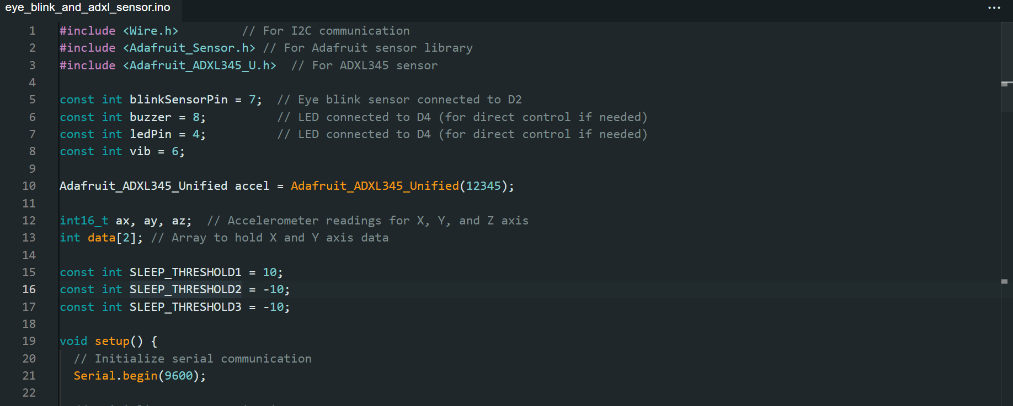

**Fig 12.1**

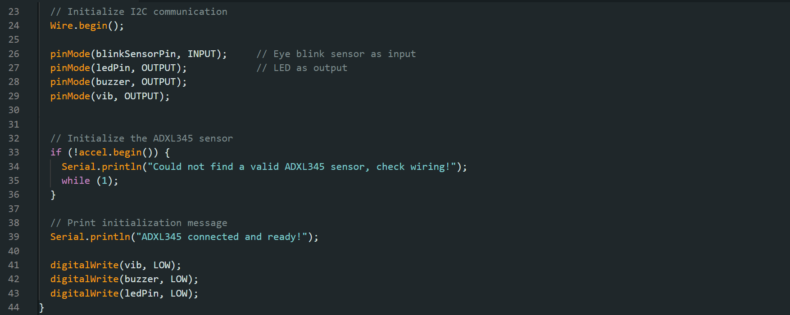

**Fig 12.2**

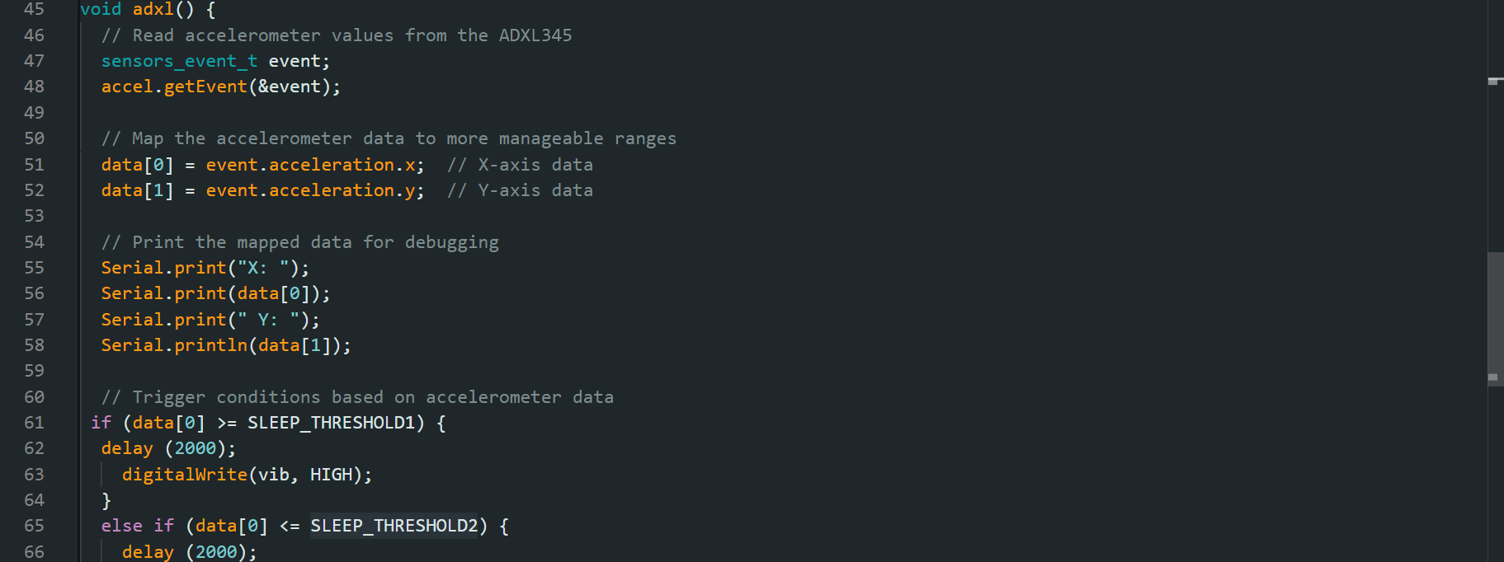

**Fig 12.3**

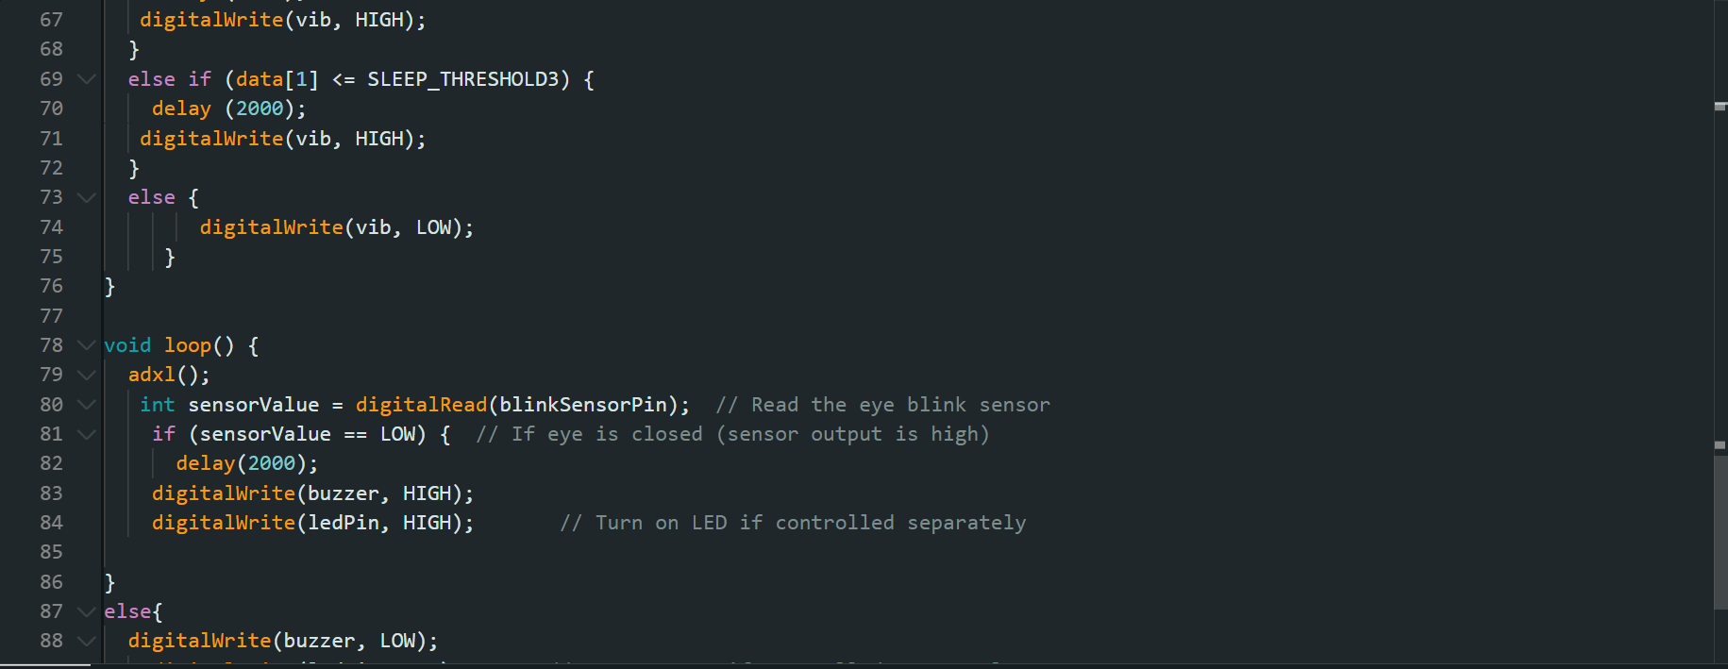

**Fig 12.4**

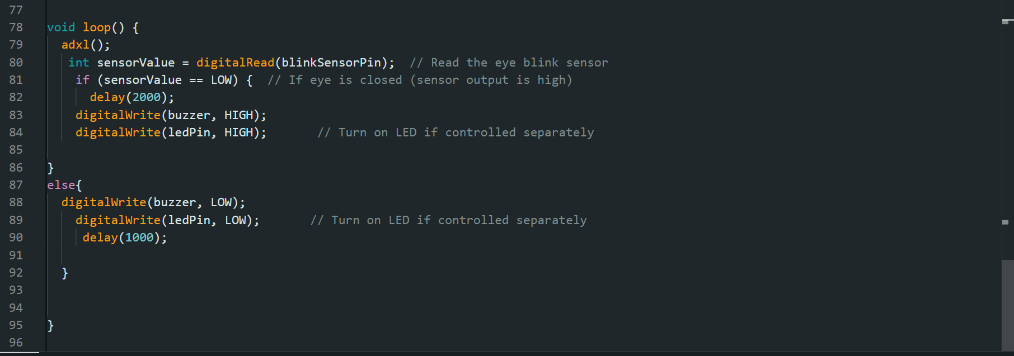

**Fig 12.5**

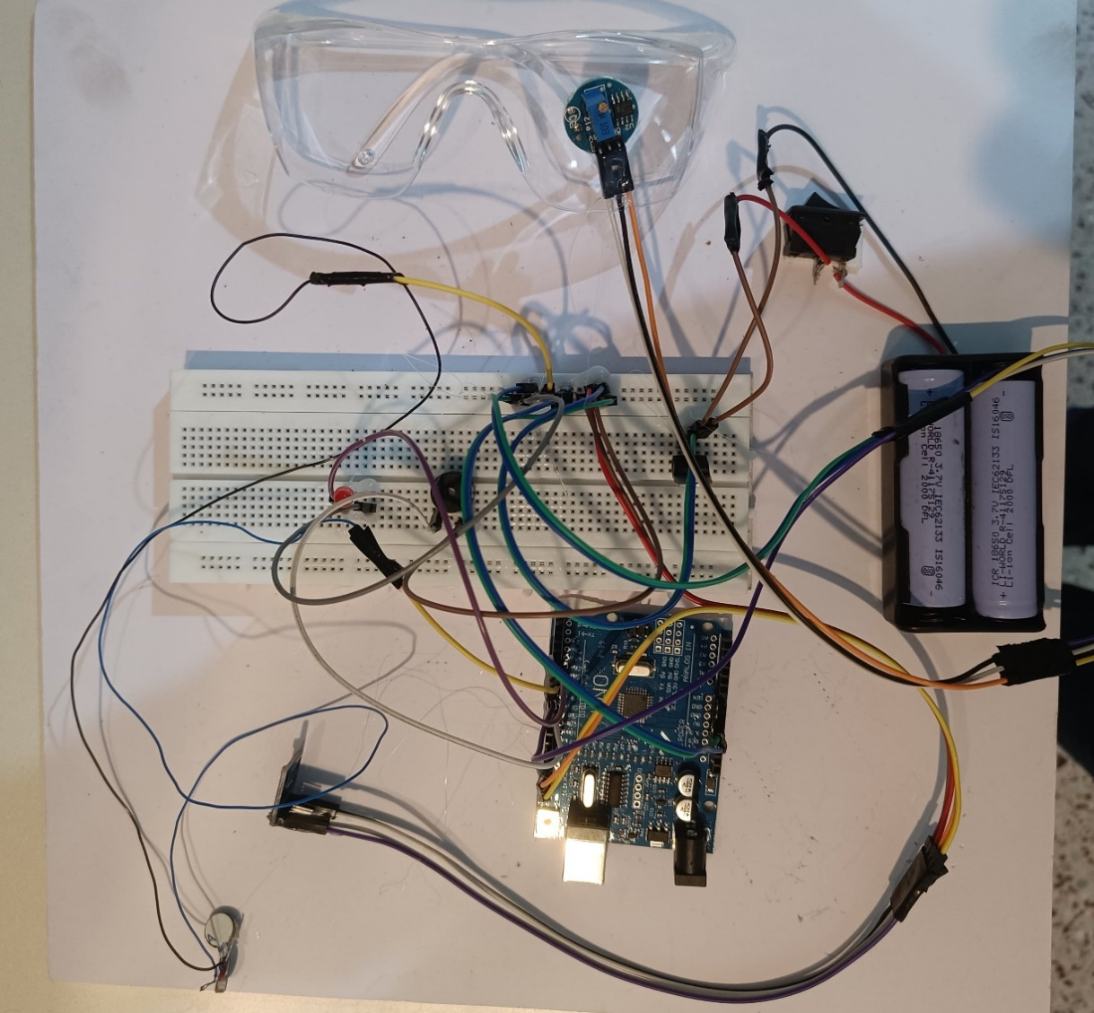

**Fig 12.6 Connected Circuit**

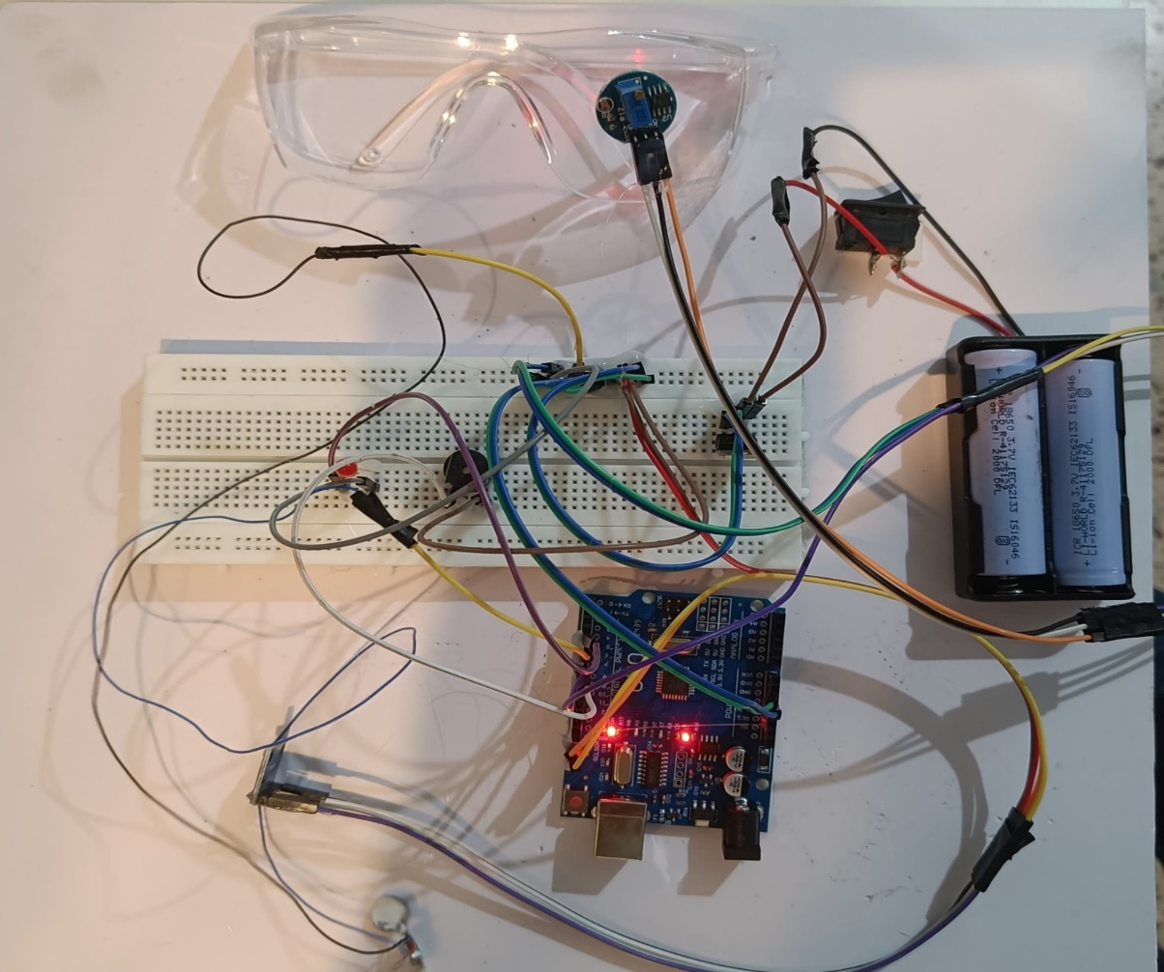

**Fig 12.7 Connected Circuit turned on**

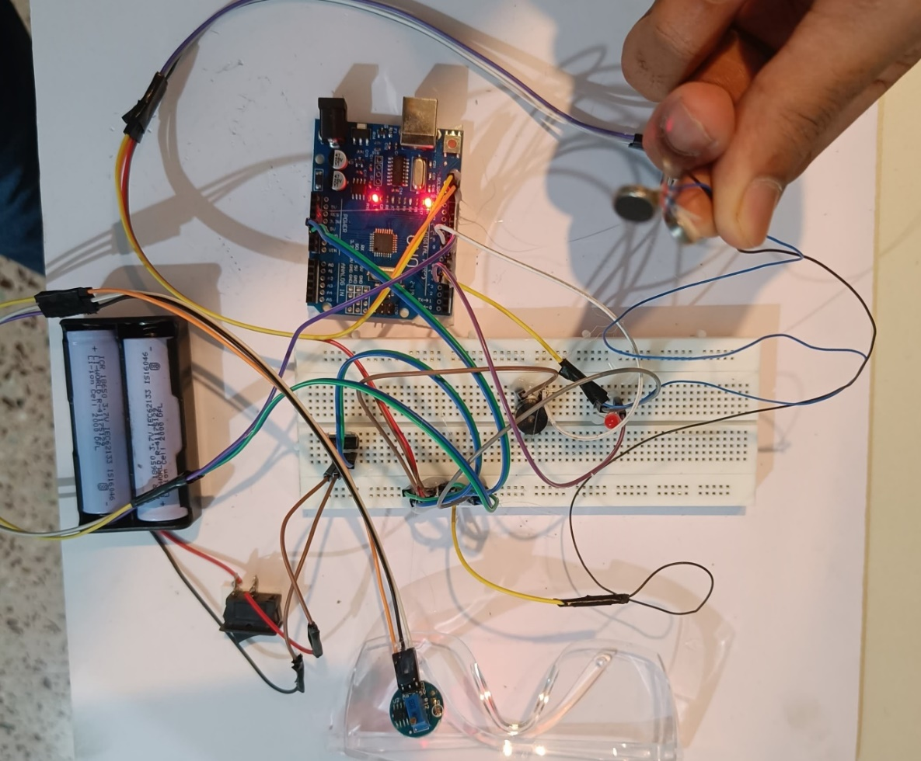

**Fig 12.8 Connected Circuit in ON mode**